**Experiment -1­­­­**

**Aim:** Develop a college website using HTML and CSS in a user-friendly and responsive design.

**Tools Used:** HTML , CSS

**Description:**

**HTML (Hypertext Markup Language)**

* HTML is the standard language for creating and structuring content on the web.
* HTML uses a system of tags (e.g., <h1>, <p>, <a>) to define elements like headings, paragraphs, and links.
* It provides the skeleton of a webpage, organizing content into sections, headers, footers, and more.
* HTML uses semantic elements like <header>, <footer>, and <article> to improve readability and accessibility.
* HTML allows the creation of clickable links to navigate between pages or external sites.

**CSS (Cascading Style Sheets)**

* CSS is used to control the presentation, layout, and design of a website, such as colors, fonts, and spacing.
* CSS separates the structure (HTML) from the appearance, making websites easier to maintain and design.
* CSS can be used to make websites adapt to different screen sizes using media queries, ensuring a good user experience on all devices.
* CSS provides tools for positioning and arranging content, such as grids, flexbox, and positioning techniques.
* It allows for animations, transitions, and hover effects to enhance the interactivity and appeal of web pages.

**Code :**

<!DOCTYPE html>

<html lang="en">

<head>

    <meta charset="UTF-8">

    <meta name="viewport" content="width=device-width, initial-scale=1.0">

    <title>College Website</title>

    <link rel="stylesheet" href="main.css">

</head>

<body>

    <!-- Header Section -->

    <header>

        <img src="https://th.bing.com/th/id/R.58d64d89eba450a43fd4282775e0ac4b?rik=8AvL4EJ%2bU1LuWA&riu=http%3a%2f%2fwww.pvpsiddhartha.ac.in%2fnew_images%2fhead.jpg&ehk=thIpMZpxadsWsNdvTnhBDZbBfECkF8ZyCxZIK8aaYw8%3d&risl=&pid=ImgRaw&r=0" alt="College Header Image" class="header-img">

        <nav>

            <ul>

                <li><a href="main.html">Home</a></li>

                <li><a href="departments.html">Departments</a></li>

                <li><a href="about.html">About</a></li>

                <li><a href="student_corner.html">Student Corner</a></li>

                <li><a href="curriculum.html">Curriculum</a></li>

            </ul>

        </nav>

    </header>

    <!-- Main Content Section -->

    <main>

        <!-- Home Section -->

        <section id="home" class="image-background">

            <h1>Welcome to Our College</h1>

            <p>Empowering students to reach their full potential through quality education and innovative learning.</p>

        </section>

<!-- Sliding Images Section -->

<section class="type">

    <h1>HIGHLIGHTS</h1>

    <p>Explore the beauty of engaging with our college community!!!</p>

</section>

<section id="student-corner" class="sliding-images">

    <div class="slider-wrapper">

        <div class="slide">

            <img src="https://www.pvpsiddhartha.ac.in/new_images/Banner%20sih.jpg" alt="Campus Life">

        </div>

        <div class="slide">

            <img src="https://www.pvpsiddhartha.ac.in/new_images/BHUPATHI%20PREM%20SAI.png" alt="Laboratories">

        </div>

        <div class="slide">

            <img src="https://www.pvpsiddhartha.ac.in/new_images/viksit_bharat_2047.jpg" alt="Sports">

        </div>

        <div class="slide">

            <img src="https://www.pvpsiddhartha.ac.in/new_images/2022-23%206plus.jpg" alt="Library">

        </div>

        <div class="slide">

            <img src="https://www.pvpsiddhartha.ac.in/new_images/last%203%20years%20top%205.jpg" alt="Laboratories">

        </div>

        <div class="slide">

            <img src="https://www.pvpsiddhartha.ac.in/new_images/p2.jpg" alt="Laboratories">

        </div>

    </div>

</section>

    </main>

    <!-- Footer Section -->

    <footer>

        <p>&copy; 2024 Our College. All Rights Reserved.</p>

        <p>Contact us: info@college.edu | +91-123-456-7890</p>

    </footer>

</body>

</html>

/* main.css */

* {

    margin: 0;

    padding: 0;

    box-sizing: border-box;

}

body {

    font-family: Arial, sans-serif;

    line-height: 1.6;

    color: #333;

}

/* Header Section */

header {

    position: relative;

    width: 100%;

    /* height:100px; */

    background-color: #003366;

}

.header-img {

    width: 100%;

    height: 170px;

    object-fit: cover;

}

nav {

    background-color: #003366;

    text-align: center;

    padding: 10px 0;

}

nav ul {

    list-style: none;

    display: flex;

    justify-content: center;

    gap: 20px;

}

nav ul li a {

    color: #fff;

    text-decoration: none;

    font-size: 18px;

    padding: 5px 10px;

    transition: color 0.3s ease;

}

nav ul li a:hover {

    color: #FFD700;

}

/* Image Background Section */

.image-background {

    background-image: url('https://image3.mouthshut.com/images/Restaurant/Photo/-12509_62259.jpg');

    background-size: cover;

    background-position: center;

    height: 700px;

    text-align: center;

    color: #040404;

    display: flex;

    flex-direction: column;

    justify-content: center;

    align-items: center;

    padding: 20px;

    /* margin-top: 50px; */

}

.image-background h1 {

    font-size: 36px;

    margin-bottom: 10px;

    /* padding-bottom: 300px; */

}

.image-background p {

    font-size: 18px;

    padding-bottom: 500px;

}

/* Highlights Section */

.type {

    text-align: center; /* Centers the content horizontally */

    margin: 50px 0; /* Adds space above and below the section */

    font-family: Arial, sans-serif; /* Sets a clean, modern font */

}

.type h1 {

    font-size: 2.5rem; /* Large size for the heading */

    font-weight: 600; /* Makes the heading slightly bold */

    color: #000; /* Black color for the heading */

    margin-bottom: 10px; /* Adds space below the heading */

}

.type p {

    font-size: 1.2rem; /* Slightly larger font size for the paragraph */

    color: #555; /* Dark gray for softer text color */

    line-height: 1.5; /* Improves readability with increased line spacing */

    margin: 0; /* Removes any default margin */

}

/* Content Sections */

.content-section {

    padding: 50px 20px;

    text-align: center;

}

h2 {

    font-size: 28px;

    margin-bottom: 20px;

    color: #003366;

}

.component-container {

    display: flex;

    justify-content: space-around;

    flex-wrap: wrap;

    gap: 20px;

}

.component {

    background-color: #003366;

    color: white;

    padding: 20px;

    border-radius: 5px;

    cursor: pointer;

    flex: 1;

    max-width: 200px;

    text-align: center;

    transition: background-color 0.3s;

}

.component:hover {

    background-color: #FFD700;

    color: #003366;

}/* Sliding Images Section */

.sliding-images {

    position: relative;

    overflow: hidden;

    width: 100%;

    height: 100vh; /* Full viewport height */

    display: flex;

    align-items: center;

    justify-content: center;

    margin-top: 20px;

}

.slider-wrapper {

    display: flex;

    width: calc(100% * 6); /* Number of slides times 100% */

    animation: scroll-left 40s linear infinite; /* Adjust speed as needed */

}

.slide {

    flex: 0 0 100%; /* Each slide takes up 100% of the viewport width */

}

.sliding-images img {

    width: 100%;

    height: auto; /* Maintain aspect ratio */

    max-height: 100vh; /* Prevent image from exceeding viewport height */

    object-fit: cover; /* Ensures the image covers the container */

}

/* Keyframes for smooth left scrolling */

@keyframes scroll-left {

    0% {

        transform: translateX(0); /* Start at the first image */

    }

    100% {

        transform: translateX(-600%); /* Move left by the width of all images */

    }

}

/* Footer Section */

footer {

    background-color: #003366;

    color: white;

    text-align: center;

    padding: 20px;

    margin-top: 20px;

}

footer p {

    margin: 5px 0;

}

<!DOCTYPE html>

<html lang="en">

<head>

    <meta charset="UTF-8">

    <meta name="viewport" content="width=device-width, initial-scale=1.0">

    <title>About Us | College Website</title>

    <link rel="stylesheet" href="about.css">

</head>

<body>

    <!-- Header Section -->

    <header>

        <img src="https://th.bing.com/th/id/R.58d64d89eba450a43fd4282775e0ac4b?rik=8AvL4EJ%2bU1LuWA&riu=http%3a%2f%2fwww.pvpsiddhartha.ac.in%2fnew_images%2fhead.jpg&ehk=thIpMZpxadsWsNdvTnhBDZbBfECkF8ZyCxZIK8aaYw8%3d&risl=&pid=ImgRaw&r=0" alt="College Header Image" class="header-img">

        <nav>

            <ul>

                <li><a href="main.html">Home</a></li>

                <li><a href="departments.html">Departments</a></li>

                <li><a href="about.html" class="active">About</a></li>

                <li><a href="student_corner.html">Student Corner</a></li>

                <li><a href="curriculum.html">Curriculum</a></li>

            </ul>

        </nav>

    </header>

     <!-- About Us Section -->

     <main>

        <section class="intro">

            <h1>About Our College</h1>

            <p>Welcome to [Your College Name], where education meets innovation. Our institution has a legacy of excellence in academics, research, and holistic development.</p>

            <img src="https://www.pvpsiddhartha.ac.in/new_images/about.jpg" alt="College Campus">

            <p>Prasad V Potluri Siddhartha Institute of Technology established in 1998 is a pioneering  The student has every opportunity in participating NSS and NCC activities. A Plethora of opportunities are available to the student for participating in various literary and cultural events that enable them to improve their communication skills and organizational abilities. Gender equity is promoted through the Women's cell. Students play an active role in all aspects of Academic and Administrative bodies through the Students council.</p>

        </section>

        <section class="content-section">

            <!-- <div class="content-row">

            </div> -->

            <div class="content-row reverse">

                <p>Our vision is to be a globally recognized institution, nurturing students to excel academically and ethically while contributing to society's betterment.</p>

                <img src="https://www.gnapgcollege.in/Content/2_vision.jpeg" alt="Students Engaged in Activities">

            </div>

            <div class="content-row">

                <img src="https://www.pvpsiddhartha.ac.in/dep_mech/docs/lab/mectronics.jpg" alt="Modern Labs and Classrooms">

                <p>We take pride in offering world-class infrastructure, including modern labs, libraries, and digital classrooms, to ensure that our students get the best education possible.</p>

            </div>

            <div class="content-row reverse">

                <p>Our placement records speak for themselves, with top recruiters from across industries hiring our students year after year. We prepare students to lead and succeed in the real world.</p>

                <img src="https://www.pvpsiddhartha.ac.in/placement_icons/rec_icons_21_22f.png" alt="Placement Drives">

            </div>

        </section>

        <section class="contact">

            <h2>Contact Us</h2>

            <p>For more information, feel free to get in touch with us.</p>

            <p><strong>Address:</strong> [College Address, City, State, ZIP]</p>

            <p><strong>Email:</strong> info@college.edu</p>

            <p><strong>Phone:</strong> +91-123-456-7890</p>

        </section>

    </main>

    <!-- Footer -->

    <footer>

        <p>&copy; 2024 [Your College Name]. All Rights Reserved.</p>

    </footer>

</body>

</html>

/* About.css */

* {

    margin: 0;

    padding: 0;

    box-sizing: border-box;

}

body {

    font-family: Arial, sans-serif;

    color: #333;

    line-height: 1.6;

    background-color: #ffffff;

}

/* Header Section */

header {

    background-color: #003366;

}

.header-img {

    width: 100%;

    height: 170px;

    object-fit: cover;

}

nav {

    background-color: #003366;

    text-align: center;

    padding: 10px 0;

}

nav ul {

    list-style: none;

    display: flex;

    justify-content: center;

    gap: 20px;

}

nav ul li a {

    color: #fff;

    text-decoration: none;

    font-size: 18px;

    padding: 5px 10px;

    transition: color 0.3s ease;

}

nav ul li a:hover, .active {

    color: #FFD700;

}

/* Intro Section */

.intro {

    text-align: center;

    padding: 40px 20px;

    background-color: #fff;

}

.intro h1 {

    font-size: 36px;

    color: #003366;

    margin-bottom: 20px;

}

.intro p {

    font-size: 18px;

    color: #555;

    padding: 30px;

    margin: 35px;

}

.intro img {

    width: 30%;

    border-radius: 10px;

    box-shadow: 0 4px 6px rgba(0, 0, 0, 0.1);

}

/* Content Section */

.content-section {

    padding: 40px 20px;

}

.content-row {

    display: flex;

    align-items: center;

    gap: 20px;

    margin-bottom: 40px;

    padding: 0 10%;

}

.content-row img {

    width: 50%;

    border-radius: 10px;

    box-shadow: 0 4px 6px rgba(0, 0, 0, 0.1);

}

.content-row p {

    font-size: 18px;

    width: 50%;

    color: #555;

}

.content-row.reverse {

    flex-direction: row-reverse;

}

/* Contact Section */

.contact {

    text-align: center;

    padding: 40px 20px;

    background-color: #003366;

    color: white;

}

.contact h2 {

    font-size: 28px;

    margin-bottom: 10px;

}

.contact p {

    margin: 10px 0;

    font-size: 18px;

}

/* Footer */

footer {

    background-color: #003366;

    color: white;

    text-align: center;

    padding: 20px;

}

<!DOCTYPE html>

<html lang="en">

<head>

    <meta charset="UTF-8">

    <meta name="viewport" content="width=device-width, initial-scale=1.0">

    <title>Departments | College Website</title>

    <link rel="stylesheet" href="departments.css">

</head>

<body>

    <!-- Header Section -->

    <header>

        <img src="https://th.bing.com/th/id/R.58d64d89eba450a43fd4282775e0ac4b?rik=8AvL4EJ%2bU1LuWA&riu=http%3a%2f%2fwww.pvpsiddhartha.ac.in%2fnew_images%2fhead.jpg&ehk=thIpMZpxadsWsNdvTnhBDZbBfECkF8ZyCxZIK8aaYw8%3d&risl=&pid=ImgRaw&r=0" alt="College Header Image" class="header-img">

        <nav>

            <ul>

                <li><a href="main.html">Home</a></li>

                <li><a href="departments.html" class="active">Departments</a></li>

                <li><a href="about.html">About</a></li>

                <li><a href="student_corner.html">Student Corner</a></li>

                <li><a href="curriculum.html">Curriculum</a></li>

            </ul>

        </nav>

    </header>

    <!-- Main Content Section -->

    <main>

        <section class="departments-section">

            <h1>Our Departments</h1>

            <p>Explore the various departments that make up our college and provide a wide range of educational opportunities.</p>

            <div class="departments-grid">

                <!-- Department Card -->

                <div class="department-card">

                    <img src="https://cdn.wallpapersafari.com/96/84/01y4VZ.jpg" alt="Computer Science">

                    <div class="card-content">

                        <h3>Computer Science & Engineering</h3>

                        <p>Innovating the future through cutting-edge technology and software development.</p>

                    </div>

                </div>

                <div class="department-card">

                    <img src="https://th.bing.com/th/id/OIP.7Tfcsj8S42q5tKgmhX1CMwHaEX?rs=1&pid=ImgDetMain" alt="Computer Science">

                    <div class="card-content">

                        <h3>Information Technology</h3>

                        <p>Innovating the future through cutting-edge technology and software development.</p>

                    </div>

                </div>

                <div class="department-card">

                    <img src="https://th.bing.com/th/id/OIP.5p-w7TVocjHtmvhxyA_1KgAAAA?w=251&h=201&rs=1&pid=ImgDetMain" alt="Computer Science">

                    <div class="card-content">

                        <h3>CSE - Data Science</h3>

                        <p>Innovating the future through cutting-edge technology and software development.</p>

                    </div>

                </div>

                <div class="department-card">

                    <img src="https://static.vecteezy.com/system/resources/previews/003/070/061/non_2x/ai-artificial-intelligence-logo-artificial-intelligence-vector.jpg" alt="Computer Science">

                    <div class="card-content">

                        <h3>CSE- Artificial Intelligence</h3>

                        <p>Innovating the future through cutting-edge technology and software development.</p>

                    </div>

                </div>

                <!-- Department Card -->

                <div class="department-card">

                    <img src="https://i.ytimg.com/vi/rlY6KScblDE/maxresdefault.jpg" alt="Electronics">

                    <div class="card-content">

                        <h3>Electronics & Communication Engineering</h3>

                        <p>Creating the foundation for the next generation of electronic systems and devices.</p>

                    </div>

                </div>

                <!-- Department Card -->

                <div class="department-card">

                    <img src="https://res.cloudinary.com/teepublic/image/private/s--2MCK7mOQ--/t_Preview/b_rgb:262c3a,c_lpad,f_jpg,h_630,q_90,w_1200/v1589551799/production/designs/10188313_0.jpg" alt="Mechanical">

                    <div class="card-content">

                        <h3>Mechanical Engineering</h3>

                        <p>Shaping the future with advanced engineering and innovative designs.</p>

                    </div>

                </div>

                <!-- Department Card -->

                <div class="department-card">

                    <img src="https://thumbs.dreamstime.com/b/lettering-civil-engineering-graphic-vector-illustration-suitable-t-shirts-design-clothing-hoodies-etc-203391443.jpg" alt="Civil">

                    <div class="card-content">

                        <h3>Civil Engineering</h3>

                        <p>Building a better tomorrow through sustainable infrastructure and urban planning.</p>

                    </div>

                </div>

                <!-- Department Card -->

                <div class="department-card">

                    <img src="https://th.bing.com/th/id/OIP.ejr7cs6yuJrAKB2UQ01zeQHaFj?rs=1&pid=ImgDetMain" alt="Electrical">

                    <div class="card-content">

                        <h3>Electrical & Electronics Engineering</h3>

                        <p>Powering the world with energy-efficient and intelligent electrical solutions.</p>

                    </div>

                </div>

                <!-- Department Card -->

            </div>

        </section>

    </main>

    <!-- Footer Section -->

    <footer>

        <p>&copy; 2024 Our College. All Rights Reserved.</p>

        <p>Contact us: info@college.edu | +91-123-456-7890</p>

    </footer>

</body>

</html>

/* departments.css */

* {

    margin: 0;

    padding: 0;

    box-sizing: border-box;

}

body {

    font-family: Arial, sans-serif;

    line-height: 1.6;

    color: #333;

    background-color: #f9f9f9;

}

/* Header Section */

header {

    position: relative;

    width: 100%;

    background-color: #003366;

}

.header-img {

    width: 100%;

    height: 170px;

    object-fit: cover;

}

nav {

    background-color: #003366;

    text-align: center;

    padding: 10px 0;

}

nav ul {

    list-style: none;

    display: flex;

    justify-content: center;

    gap: 20px;

}

nav ul li a {

    color: #fff;

    text-decoration: none;

    font-size: 18px;

    padding: 5px 10px;

    transition: color 0.3s ease;

}

nav ul li a:hover, .active {

    color: #FFD700;

}

/* Departments Section */

.departments-section {

    padding: 50px 20px;

    text-align: center;

    background-color: #fff;

    box-shadow: 0 4px 8px rgba(0, 0, 0, 0.1);

    margin: 20px;

    border-radius: 10px;

}

.departments-section h1 {

    font-size: 36px;

    color: #003366;

    margin-bottom: 10px;

}

.departments-section p {

    font-size: 18px;

    margin-bottom: 30px;

    color: #666;

}

/* Departments Grid */

.departments-grid {

    display: grid;

    grid-template-columns: repeat(auto-fit, minmax(300px, 1fr));

    gap: 20px;

    padding: 0 10px;

}

/* Department Card */

.department-card {

    background-color: #fff;

    border-radius: 10px;

    box-shadow: 0 4px 6px rgba(0, 0, 0, 0.1);

    overflow: hidden;

    transition: transform 0.3s, box-shadow 0.3s;

}

.department-card:hover {

    transform: translateY(-5px);

    box-shadow: 0 8px 12px rgba(0, 0, 0, 0.2);

}

.department-card img {

    width: 100%;

    height: 200px;

    object-fit: cover;

}

.card-content {

    padding: 15px;

    text-align: center;

}

.card-content h3 {

    font-size: 20px;

    color: #003366;

    margin-bottom: 10px;

}

.card-content p {

    font-size: 16px;

    color: #666;

}

/* Footer Section */

footer {

    background-color: #003366;

    color: white;

    text-align: center;

    padding: 20px;

    margin-top: 40px;

}

footer p {

    margin: 5px 0;

}

<!DOCTYPE html>

<html lang="en">

<head>

    <meta charset="UTF-8">

    <meta name="viewport" content="width=device-width, initial-scale=1.0">

    <title>Curriculum | PVPSIT College</title>

    <link rel="stylesheet" href="curriculum.css">

</head>

<body>

    <!-- Header Section -->

    <header>

        <img src="https://th.bing.com/th/id/R.58d64d89eba450a43fd4282775e0ac4b?rik=8AvL4EJ%2bU1LuWA&riu=http%3a%2f%2fwww.pvpsiddhartha.ac.in%2fnew_images%2fhead.jpg&ehk=thIpMZpxadsWsNdvTnhBDZbBfECkF8ZyCxZIK8aaYw8%3d&risl=&pid=ImgRaw&r=0" alt="College Header Image" class="header-img">

        <nav>

            <ul>

                <li><a href="main.html">Home</a></li>

                <li><a href="departments.html">Departments</a></li>

                <li><a href="about.html">About</a></li>

                <li><a href="student_corner.html">Student Corner</a></li>

                <li><a href="curriculum.html" class="active">Curriculum</a></li>

            </ul>

        </nav>

    </header>

    <!-- Main Curriculum Section -->

    <main>

        <section class="intro">

            <h1>Curriculum Overview</h1>

            <p>Our curriculum is structured to provide comprehensive knowledge and hands-on experience for students across all branches of engineering. Explore the curriculum for each branch below.</p>

        </section>

        <section class="curriculum-branches">

            <!-- Computer Science -->

            <div class="branch">

                <h2>Computer Science Engineering (CSE)</h2>

                <div class="semester">

                    <h3>Semester 1 & 2</h3>

                    <ul>

                        <li>Programming for Problem Solving</li>

                        <li>Engineering Mathematics - I & II</li>

                        <li>Basic Electrical & Electronics Engineering</li>

                        <li>Engineering Physics / Chemistry</li>

                    </ul>

                </div>

                <div class="semester">

                    <h3>Semester 3 & 4</h3>

                    <ul>

                        <li>Data Structures</li>

                        <li>Database Management Systems</li>

                        <li>Computer Organization</li>

                        <li>Discrete Mathematics</li>

                    </ul>

                </div>

                <div class="semester">

                    <h3>Semester 5 & 6</h3>

                    <ul>

                        <li>Operating Systems</li>

                        <li>Computer Networks</li>

                        <li>Design and Analysis of Algorithms</li>

                        <li>Artificial Intelligence</li>

                    </ul>

                </div>

                <div class="semester">

                    <h3>Semester 7 & 8</h3>

                    <ul>

                        <li>Machine Learning</li>

                        <li>Cybersecurity</li>

                        <li>Software Engineering</li>

                        <li>Major Project & Internship</li>

                    </ul>

                </div>

            </div>

            <!-- Electronics -->

            <div class="branch">

                <h2>Electronics & Communication Engineering (ECE)</h2>

                <div class="semester">

                    <h3>Semester 1 & 2</h3>

                    <ul>

                        <li>Engineering Mathematics - I & II</li>

                        <li>Engineering Physics / Chemistry</li>

                        <li>Electronic Devices and Circuits</li>

                        <li>Basic Electrical Engineering</li>

                    </ul>

                </div>

                <div class="semester">

                    <h3>Semester 3 & 4</h3>

                    <ul>

                        <li>Digital Electronics</li>

                        <li>Signals and Systems</li>

                        <li>Control Systems</li>

                        <li>Analog Communication</li>

                    </ul>

                </div>

                <div class="semester">

                    <h3>Semester 5 & 6</h3>

                    <ul>

                        <li>Microprocessors and Microcontrollers</li>

                        <li>Digital Signal Processing</li>

                        <li>Embedded Systems</li>

                        <li>Wireless Communication</li>

                    </ul>

                </div>

                <div class="semester">

                    <h3>Semester 7 & 8</h3>

                    <ul>

                        <li>VLSI Design</li>

                        <li>IoT Systems</li>

                        <li>Advanced Communication Systems</li>

                        <li>Major Project & Internship</li>

                    </ul>

                </div>

            </div>

            <!-- Mechanical -->

            <div class="branch">

                <h2>Mechanical Engineering (ME)</h2>

                <div class="semester">

                    <h3>Semester 1 & 2</h3>

                    <ul>

                        <li>Engineering Mathematics - I & II</li>

                        <li>Engineering Physics / Chemistry</li>

                        <li>Engineering Mechanics</li>

                        <li>Basic Electrical & Electronics Engineering</li>

                    </ul>

                </div>

                <div class="semester">

                    <h3>Semester 3 & 4</h3>

                    <ul>

                        <li>Thermodynamics</li>

                        <li>Fluid Mechanics</li>

                        <li>Strength of Materials</li>

                        <li>Manufacturing Processes</li>

                    </ul>

                </div>

                <div class="semester">

                    <h3>Semester 5 & 6</h3>

                    <ul>

                        <li>Heat Transfer</li>

                        <li>Machine Design</li>

                        <li>Mechatronics</li>

                        <li>Industrial Engineering</li>

                    </ul>

                </div>

                <div class="semester">

                    <h3>Semester 7 & 8</h3>

                    <ul>

                        <li>Automobile Engineering</li>

                        <li>Robotics</li>

                        <li>Renewable Energy Systems</li>

                        <li>Major Project & Internship</li>

                    </ul>

                </div>

            </div>

        </section>

    </main>

    <!-- Footer -->

    <footer>

        <p>&copy; 2024 PVPSIT College. All Rights Reserved.</p>

    </footer>

</body>

</html>

/* curriculum.css */

* {

    margin: 0;

    padding: 0;

    box-sizing: border-box;

}

body {

    font-family: Arial, sans-serif;

    background-color: #f9f9f9;

    color: #333;

}

/* Header Section */

header {

    background-color: #003366;

}

.header-img {

    width: 100%;

    height: 170px;

    object-fit: cover;

}

nav {

    background-color: #003366;

    text-align: center;

    padding: 10px 0;

}

nav ul {

    list-style: none;

    display: flex;

    justify-content: center;

    gap: 20px;

}

nav ul li a {

    color: white;

    text-decoration: none;

    font-size: 18px;

    padding: 5px 10px;

    transition: color 0.3s ease;

}

nav ul li a:hover, .active {

    color: #FFD700;

}

/* Intro Section */

.intro {

    text-align: center;

    padding: 40px 20px;

    background-color: #fff;

}

.intro h1 {

    font-size: 36px;

    color: #003366;

    margin-bottom: 20px;

}

.intro p {

    font-size: 18px;

    color: #555;

}

/* Curriculum Section */

.curriculum-branches {

    padding: 20px;

    max-width: 1200px;

    margin: 0 auto;

}

.branch {

    margin-bottom: 40px;

    background-color: white;

    padding: 20px;

    border-radius: 8px;

    box-shadow: 0 4px 6px rgba(0, 0, 0, 0.1);

}

.branch h2 {

    font-size: 28px;

    color: #003366;

    margin-bottom: 10px;

    border-bottom: 2px solid #003366;

    padding-bottom: 5px;

}

.semester {

    margin-top: 20px;

}

.semester h3 {

    font-size: 22px;

    color: #003366;

    margin-bottom: 10px;

}

.semester ul {

    list-style-type: disc;

    padding-left: 20px;

}

.semester ul li {

    font-size: 16px;

    color: #555;

    line-height: 1.6;

}

/* Footer */

footer {

    background-color: #003366;

    color: white;

    text-align: center;

    padding: 20px;

    margin-top: 20px;

}

<!DOCTYPE html>

<html lang="en">

<head>

    <meta charset="UTF-8">

    <meta name="viewport" content="width=device-width, initial-scale=1.0">

    <title>Student Corner</title>

    <style>

        body {

            font-family: Arial, sans-serif;

            margin: 0;

            padding: 0;

            background-color: #f4f4f9;

            color: #333;

        }

/* Header Section */

header {

    background-color: #003366;

}

.header-img {

    width: 100%;

    height: 150px;

    object-fit: cover;

}

nav {

    background-color: #003366;

    text-align: center;

    padding: 10px 0;

}

nav ul {

    list-style: none;

    display: flex;

    justify-content: center;

    gap: 20px;

}

nav ul li a {

    color: #fff;

    text-decoration: none;

    font-size: 18px;

    padding: 5px 10px;

    transition: color 0.3s ease;

}

nav ul li a:hover, .active {

    color: #FFD700;

}

        .container {

            width: 90%;

            margin: 2rem auto;

            max-width: 1200px;

            padding: 2rem;

        }

        .intro {

            text-align: center;

            margin-bottom: 2rem;

        }

        .intro img {

            width: 100%;

            max-width: 600px;

            height: auto;

            border-radius: 8px;

        }

        .content {

            display: flex;

            flex-wrap: wrap;

            gap: 2rem;

        }

        .content .section {

            flex: 1;

            min-width: 300px;

        }

        .section h2 {

            color: #0056a3;

            margin-bottom: 0.5rem;

        }

        .section ul {

            list-style: none;

            padding: 0;

        }

        .section ul li {

            background: #87a1d0;

            margin: 0.5rem 0;

            padding: 0.8rem;

            border-radius: 5px;

        }

        footer {

            background-color: #333;

            color: #fff;

            text-align: center;

            padding: 1rem 0;

            margin-top: 2rem;

        }

        footer p {

            margin: 0;

        }

    </style>

</head>

<body>

    <!-- Header Section -->

    <header>

        <img src="https://th.bing.com/th/id/R.58d64d89eba450a43fd4282775e0ac4b?rik=8AvL4EJ%2bU1LuWA&riu=http%3a%2f%2fwww.pvpsiddhartha.ac.in%2fnew_images%2fhead.jpg&ehk=thIpMZpxadsWsNdvTnhBDZbBfECkF8ZyCxZIK8aaYw8%3d&risl=&pid=ImgRaw&r=0" alt="College Header Image" class="header-img">

        <nav>

            <ul>

                <li><a href="main.html">Home</a></li>

                <li><a href="departments.html">Departments</a></li>

                <li><a href="about.html" class="active">About</a></li>

                <li><a href="student_corner.html">Student Corner</a></li>

                <li><a href="curriculum.html">Curriculum</a></li>

            </ul>

        </nav>

    </header>

    <!-- <div class="anu">

        <h1>Student Corner</h1>

    <div> -->

    <div class="container">

        <div class="intro">

            <p>Welcome to the Student Corner! This is your go-to space for all college events, clubs, and activities.</p>

            <img src="https://www.pvpsiddhartha.ac.in/student_council/images/student_council9.jpg" alt="College Event Image">

        </div>

        <div class="content">

            <div class="section">

                <h2>Upcoming Events</h2>

                <ul>

                    <li>Annual Tech Fest - Jan 25th, 2025</li>

                    <li>Cultural Evening - Feb 10th, 2025</li>

                    <li>Sports Meet - March 15th, 2025</li>

                </ul>

            </div>

            <div class="section">

                <h2>Active Clubs</h2>

                <ul>

                    <li>Robotics Club</li>

                    <li>Photography Club</li>

                    <li>Literature Society</li>

                    <li>Environmental Club</li>

                </ul>

            </div>

            <div class="section">

                <h2>Highlights</h2>

                <ul>

                    <li>State-Level Debate Champion 2024</li>

                    <li>Winners of Inter-College Coding Hackathon</li>

                    <li>Platinum Sponsorship for Tech Summit</li>

                </ul>

            </div>

        </div>

    </div>

    <footer>

        <p>&copy; 2024 Your College Name. All Rights Reserved.</p>

    </footer>

</body>

</html>

**Screenshots:**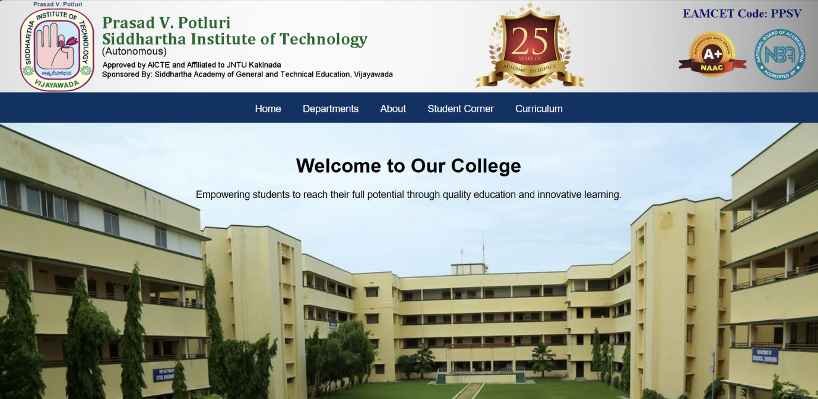

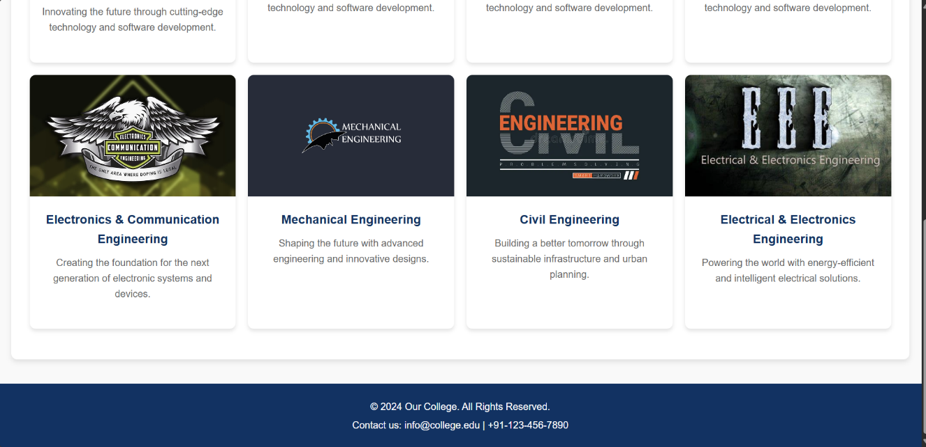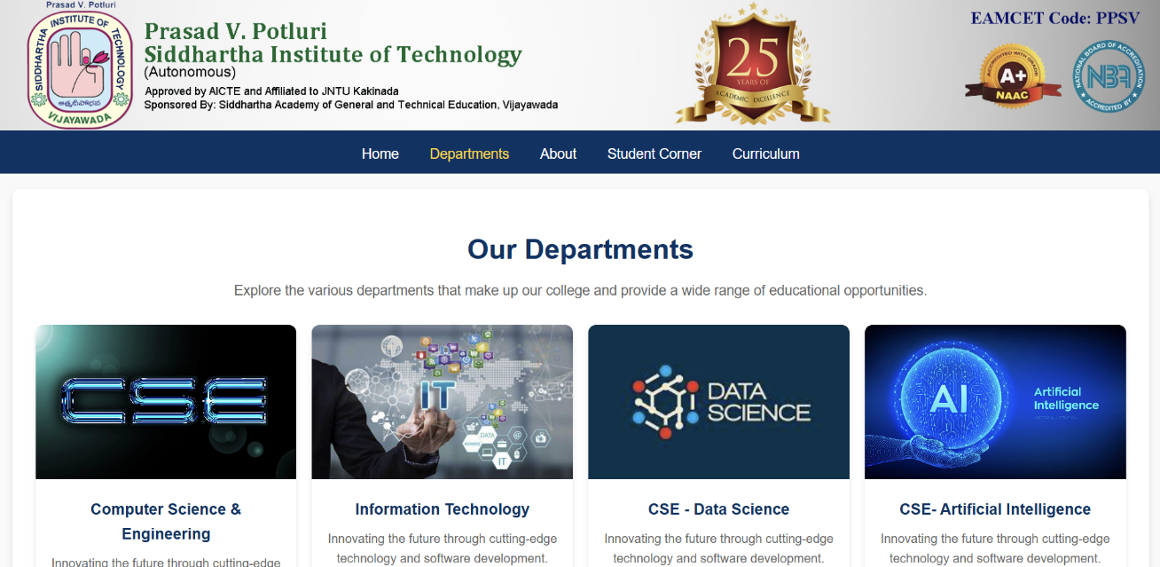**Fig 1: Home Page**

**Fig 2: Departments Page**

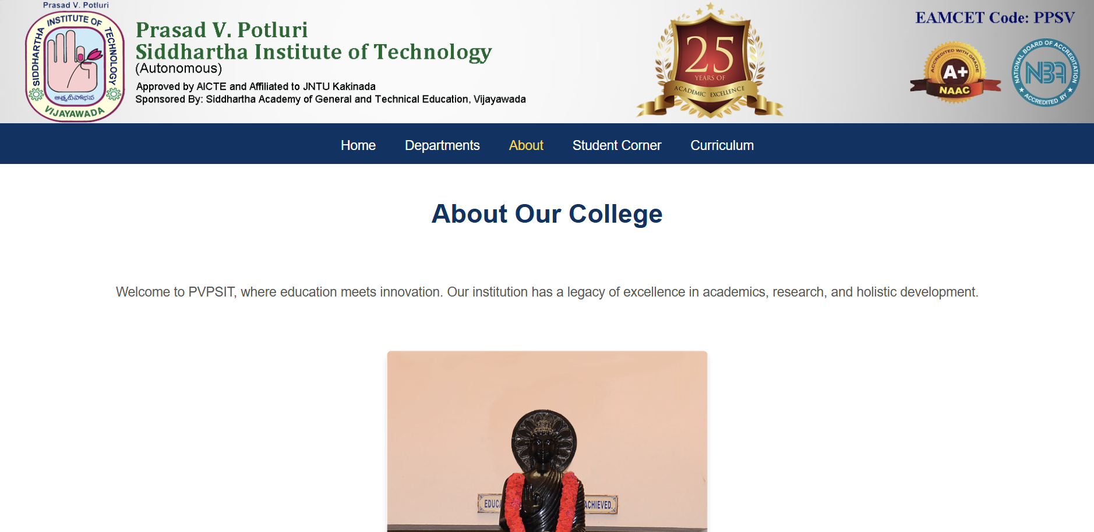  
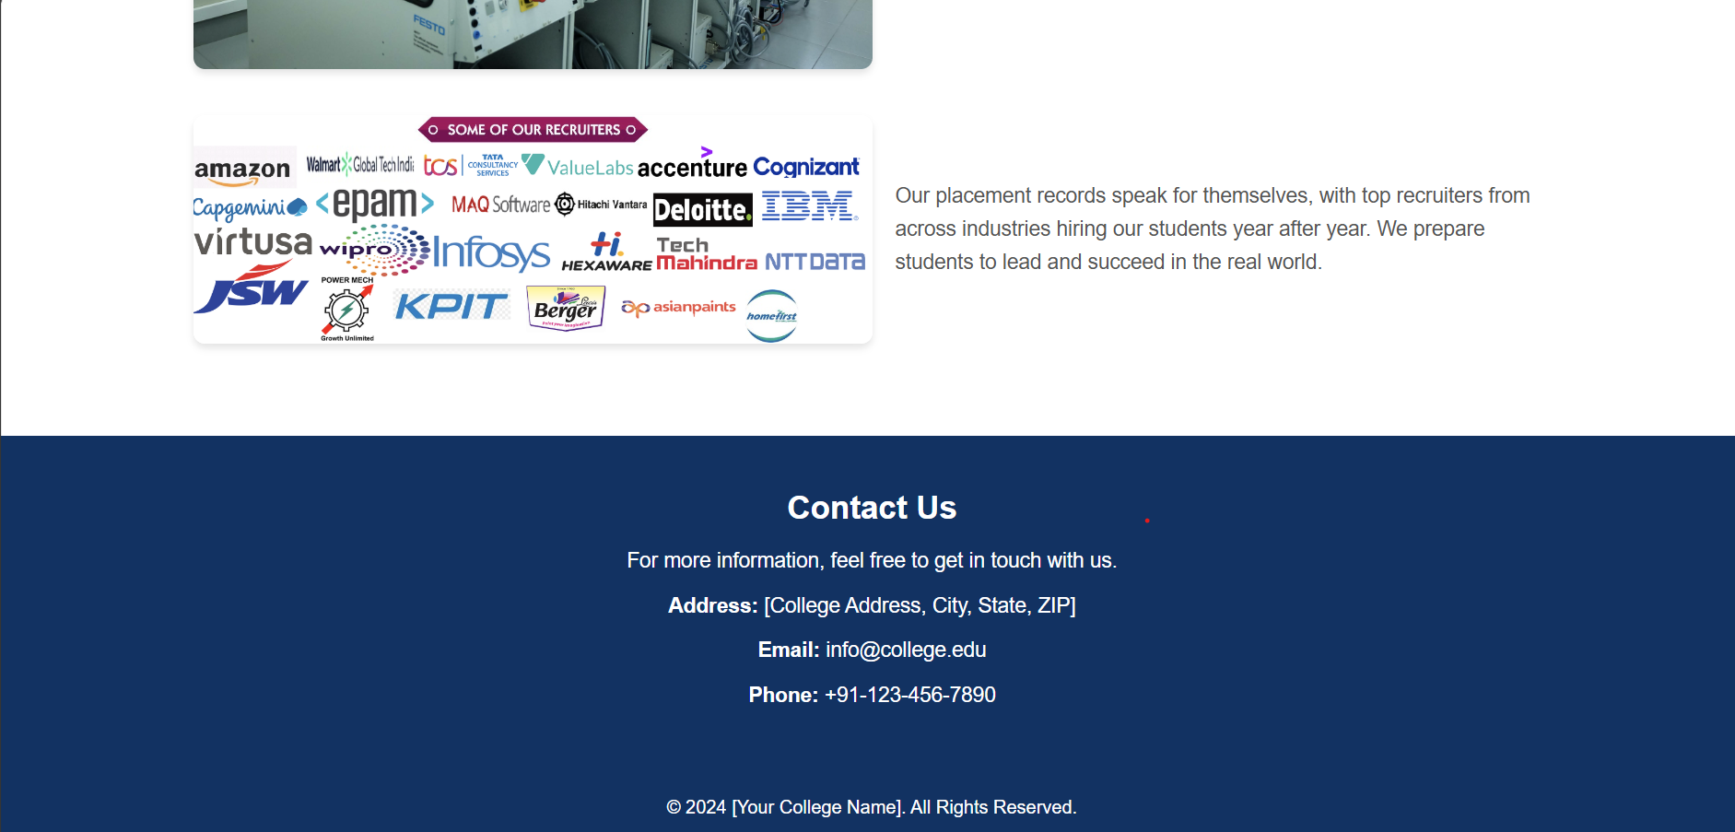**Fig -3: About Page  
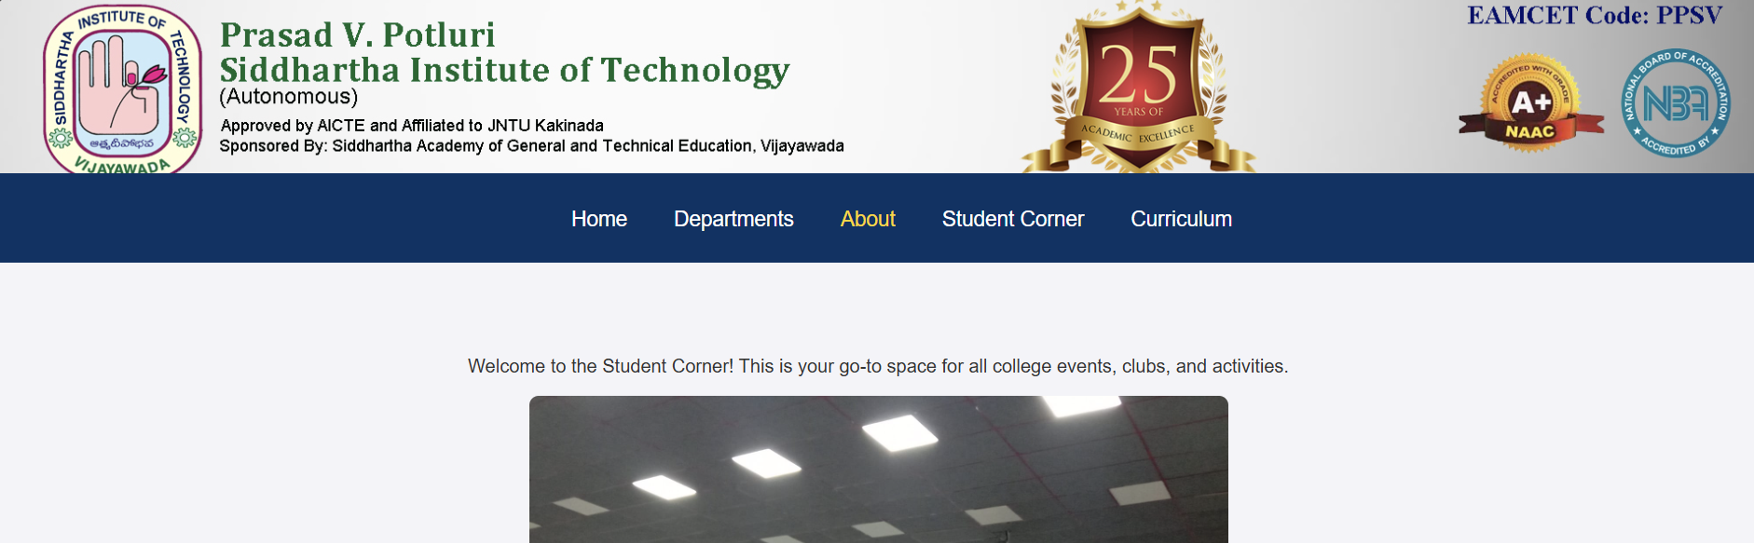**

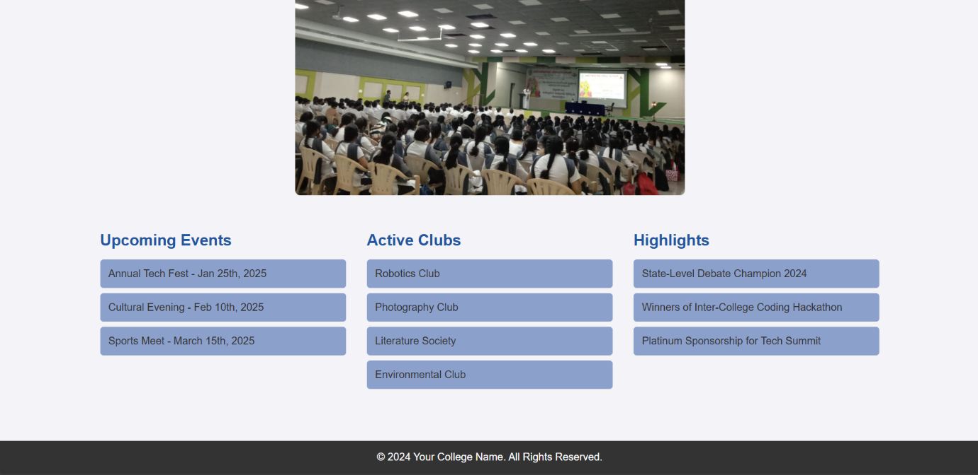**Fig 4: Student corner Page**

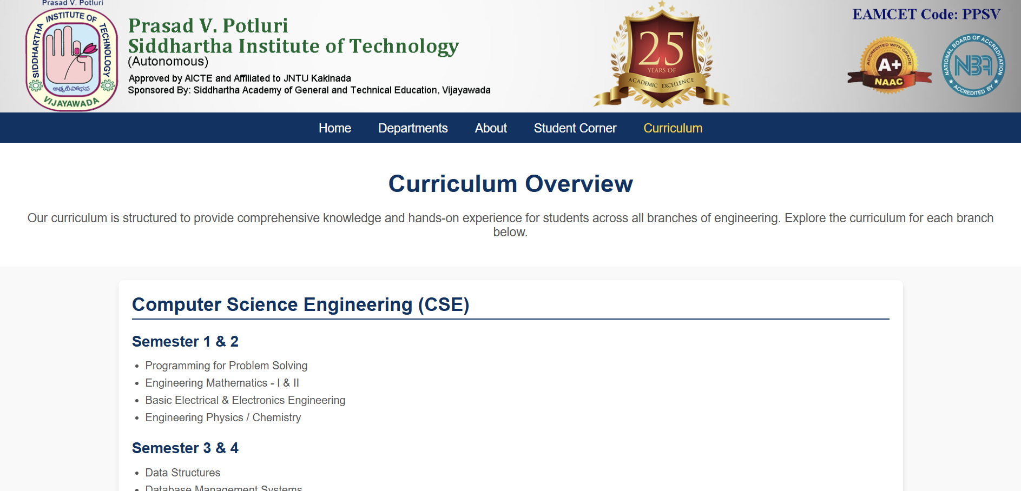

**Fig 5: Curriculum page**

**Result:**

A website of Prasad. V. Potluri Siddhartha Institute of Technology is developed using HTML and CSS.